../../Downloads/thumbnail_open.png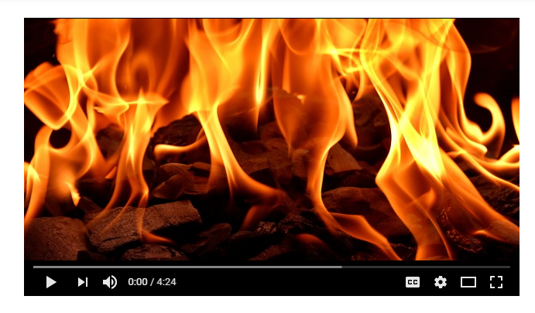

Author’s real name

Up in Smoke

A film by

Andrew Jones

TITLE